BANK LOAN REPORT QUERY DOCUMENT
- BANK LOAN REPORT | SUMMARY
KPI’s:
Total Loan Applications
SELECT COUNT(id) AS Total_Loan_Applications FROM dbo.bank_loan_data
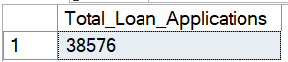
MTD Loan Applications
SELECT COUNT(id) AS MTD_Total_Loan_Applications FROM dbo.bank_loan_data
WHERE MONTH(issue_date) = 12 AND YEAR(issue_date) = 2021
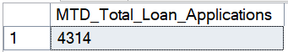
PMTD Loan Applications
SELECT COUNT(id) AS PMTD_Total_Loan_Applications FROM dbo.bank_loan_data
WHERE MONTH(issue_date) = 11 AND YEAR(issue_date) = 2021
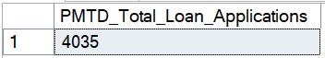

Total Funded Amount
SELECT SUM(loan_amount) AS Total_Funded_Amount FROM dbo.bank_loan_data
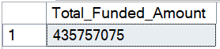
MTD Total Funded Amount
SELECT SUM(loan_amount) AS MTD_Total_Funded_Amount FROM dbo.bank_loan_data
WHERE MONTH(issue_date) = 12 AND YEAR(issue_date) = 2021
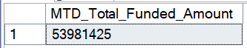
PMTD Total Funded Amount
SELECT SUM(loan_amount) AS PMTD_Total_Funded_Amount FROM dbo.bank_loan_data
WHERE MONTH(issue_date) = 11 AND YEAR(issue_date) = 2021
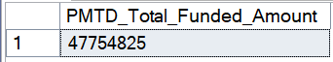

Total Amount Received
SELECT SUM(total_payment) AS Total_Amont_Recieved FROM dbo.bank_loan_data 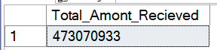
MTD Total Amount Received
SELECT SUM(total_payment) AS MTD_Total_Amont_Recieved FROM dbo.bank_loan_data
WHERE MONTH(issue_date) = 12 AND YEAR(issue_date) = 2021
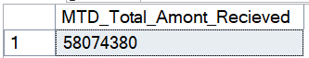
PMTD Total Amount Received
SELECT SUM(total_payment) AS PMTD_Total_Amont_Recieved FROM dbo.bank_loan_data
WHERE MONTH(issue_date) = 11 AND YEAR(issue_date) = 2021
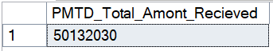
Average Interest Rate
SELECT CAST(AVG(int_rate) *100 AS DECIMAL(10,2)) AS Avg_Interest_Rate FROM dbo.bank_loan_data
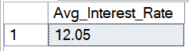
MTD Average Interest
SELECT CAST(AVG(int_rate) *100 AS DECIMAL(10,2)) AS MTD_Avg_Interest_Rate
FROM dbo.bank_loan_data
WHERE MONTH(issue_date) = 12 AND YEAR(issue_date) = 2021
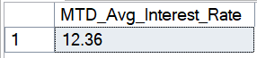
PMTD Average Interest
SELECT CAST(AVG(int_rate) *100 AS DECIMAL(10,2)) AS PMTD_Avg_Interest_Rate
FROM dbo.bank_loan_data
WHERE MONTH(issue_date) = 11 AND YEAR(issue_date) = 2021
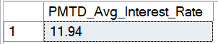

Avg DTI
SELECT ROUND(AVG(dti),4) *100 AS Avg_DTI FROM dbo.bank_loan_data

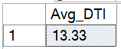
MTD Avg DTI
SELECT ROUND(AVG(dti),4) *100 AS MTD_Avg_DTI FROM dbo.bank_loan_data
WHERE MONTH(issue_date) = 12 AND YEAR(issue_date) = 2021

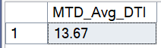
PMTD Avg DTI
SELECT ROUND(AVG(dti),4) *100 AS PMTD_Avg_DTI FROM dbo.bank_loan_data
WHERE MONTH(issue_date) = 11 AND YEAR(issue_date) = 2021

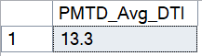

GOOD LOAN ISSUED
Good Loan Percentage
SELECT
(COUNT(CASE WHEN loan_status='Fully Paid' OR loan_status = 'Current' THEN id END) * 100.0) /
COUNT (id) AS Good_Loan_Percentage
FROM bank_loan_data
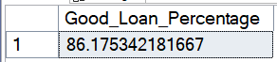
Good Loan Applications
SELECT COUNT(id) AS Good_Loan_Applications FROM bank_loan_data
WHERE loan_status = 'Fully Paid' OR loan_status = 'Current'
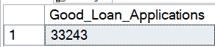
Good Loan Funded Amount
SELECT SUM(loan_amount) AS Good_Loan_Funded_Amount FROM bank_loan_data
WHERE loan_status = 'Fully Paid' OR loan_status = 'Current'
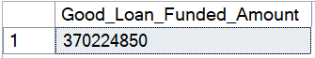

Good Loan Amount Received
SELECT SUM(total_payment) AS Good_Loan_Amount_Recieved FROM bank_loan_data
WHERE loan_status = 'Fully Paid' OR loan_status = 'Current'
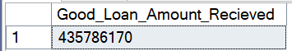

BAD LOAN ISSUED
Bad Loan Percentage
SELECT
(COUNT(CASE WHEN loan_status = 'Charged Off' THEN id END) * 100.0) /
COUNT(id) AS Bad_Loan_Percentage
FROM bank_loan_data
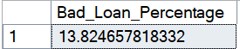
Bad Loan Applications
SELECT COUNT(id) AS Bad_Loan_Applications FROM bank_loan_data
WHERE loan_status = 'Charged Off'
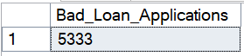
Bad Loan Funded Amount
SELECT SUM(loan_amount) AS Bad_Loan_Funded_Amount FROM bank_loan_data
WHERE loan_status = 'Charged Off'
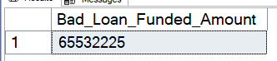
Bad Loan Amount Received
SELECT SUM(total_payment) AS Bad_Loan_Amount_Recieved FROM bank_loan_data
WHERE loan_status = 'Charged Off'
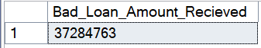

LOAN STATUS
SELECT
loan_status,
COUNT(id) AS Loan_Count,
SUM(total_payment) AS Total_Amount_Recieved,
SUM(loan_amount) AS Total_Funded_Amount,
AVG(int_rate * 100) AS Interest_Rate,
AVG(dti * 100) AS DTI
FROM
bank_loan_data
GROUP BY
loan_status 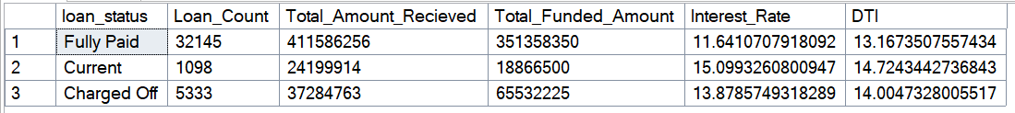

SELECT
loan_status,
SUM(total_payment) AS MTD_Total_Amount_Recieved,
SUM(loan_amount) AS MTD_Total_Funded_Amount
FROM
bank_loan_data
WHERE
MONTH(issue_date) = 12
GROUP BY
loan_status
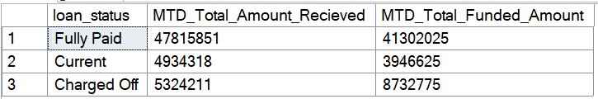

- BANK LOAN REPORT | OVERVIEW
MONTH
SELECT
MONTH(issue_date) AS Month_Num,
DATENAME(MONTH, issue_date) AS Month,
COUNT(id) AS Total_Loan_Applications,
SUM(total_payment) AS Total_Amount_Recieved,
SUM(loan_amount) AS Total_Funded_Amount
FROM bank_loan_data
GROUP BY MONTH(issue_date), DATENAME(MONTH, issue_date)
ORDER BY MONTH(issue_date) 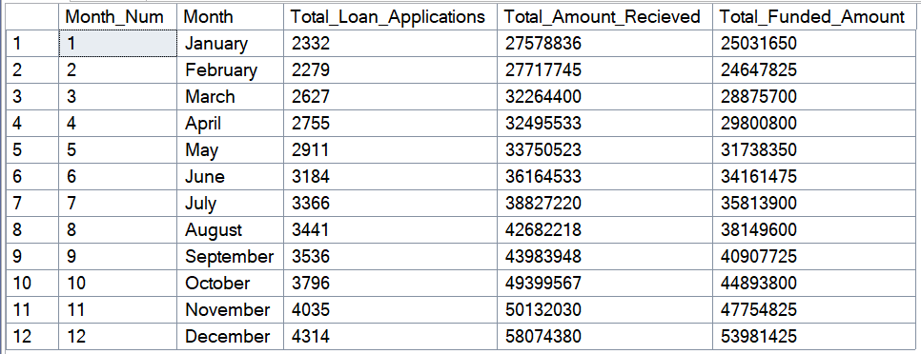

STATE
SELECT
address_state AS State,
COUNT(id) AS Total_Loan_Applications,
SUM(loan_amount) AS Total_Funded_Amount,
SUM(total_payment) AS Total_Amount_Received
FROM bank_loan_data
GROUP BY address_state
ORDER BY address_state
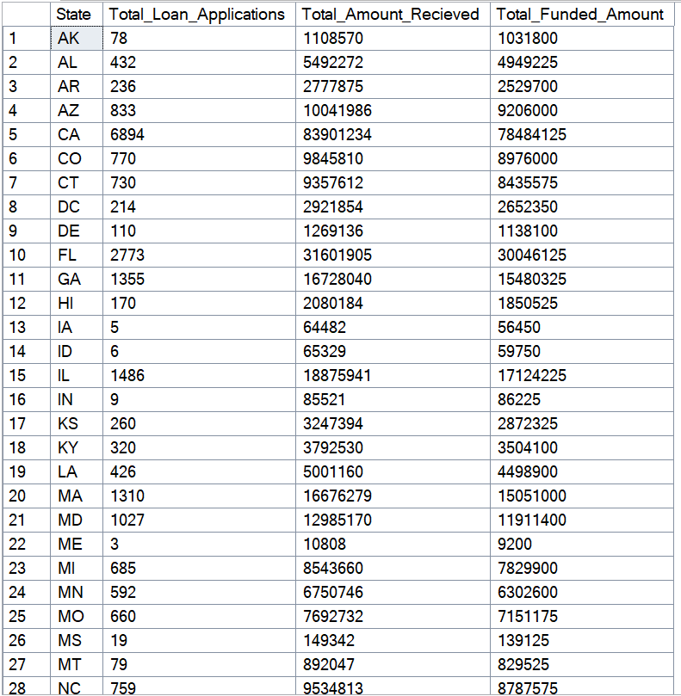
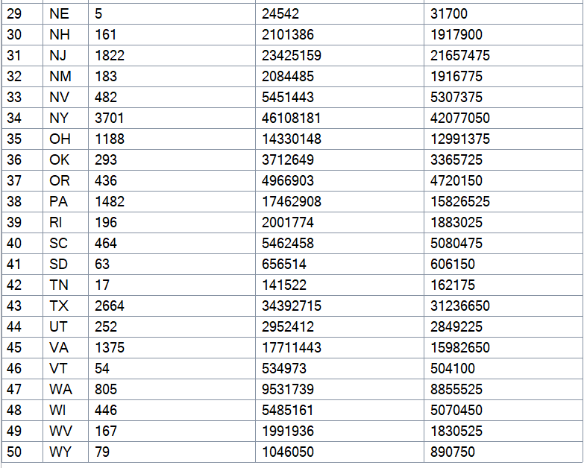
TERM
SELECT
term AS Term,
COUNT(id) AS Total_Loan_Applications,
SUM(total_payment) AS Total_Amount_Recieved,
SUM(loan_amount) AS Total_Funded_Amount
FROM bank_loan_data
GROUP BY term
ORDER BY term
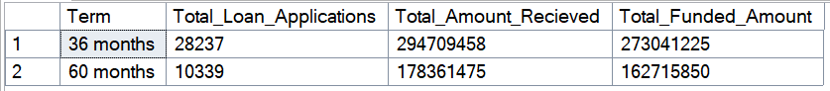
EMPLOYEE LENGTH
SELECT
emp_length AS Employee_Length,
COUNT(id) AS Total_Loan_Applications,
SUM(total_payment) AS Total_Amount_Recieved,
SUM(loan_amount) AS Total_Funded_Amount
FROM bank_loan_data
GROUP BY emp_length
ORDER BY emp_length
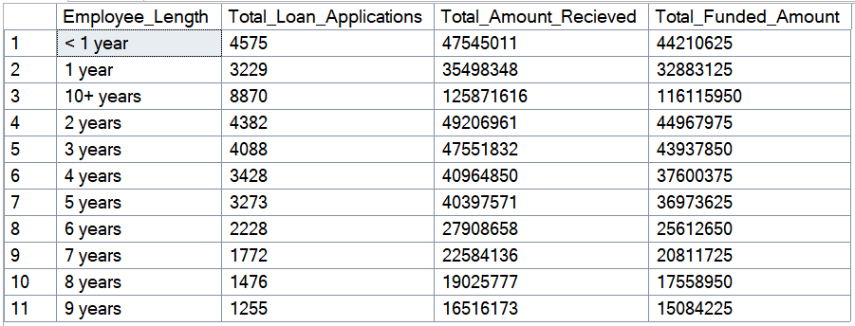
PURPOSE
SELECT
purpose AS PURPOSE,
COUNT(id) AS Total_Loan_Applications,
SUM(loan_amount) AS Total_Funded_Amount,
SUM(total_payment) AS Total_Amount_Received
FROM bank_loan_data
GROUP BY purpose
ORDER BY purpose
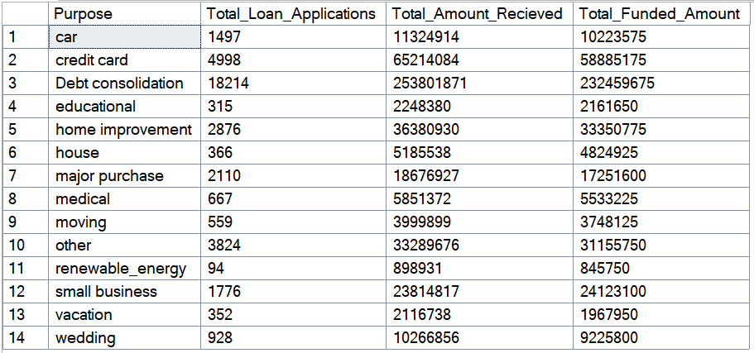
HOME OWNERSHIP
SELECT
home_ownership AS Home_Ownership,
COUNT(id) AS Total_Loan_Applications,
SUM(loan_amount) AS Total_Funded_Amount,
SUM(total_payment) AS Total_Amount_Received
FROM bank_loan_data
GROUP BY home_ownership
ORDER BY home_ownership
